Speech Update! 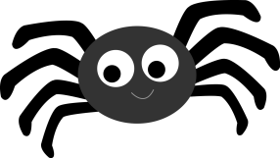

We have introduced some Halloween related /s/ blend words including “spooky”, “scary”, and “spider” !!

We call the /s/ sound the “snake “ sound. It is important that your child makes the “snake” sound with his/ her tongue BEHIND the teeth and that the teeth are completely together. 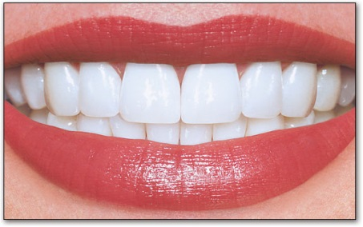

Practice using the “snake” sound at home. Even if your child can just do the snake sound by itself, that is OK!

Have fun!

Speech Update! 

We have introduced some Halloween related /s/ blend words including “spooky”, “scary”, and “spider” !!

We call the /s/ sound the “snake “ sound. It is important that your child makes the “snake” sound with his/ her tongue BEHIND the teeth and that the teeth are completely together. 

Practice using the “snake” sound at home. Even if your child can just do the snake sound by itself, that is OK!

Have fun!